**Project Design Phase-II Technology Stack (Architecture & Stack)**

|  |  |
| --- | --- |
| Date | 15 October 2022 |
| Team ID | PNT2022TMID17653 |
| Project Name | Project - Smart Fashion Recommender  Application |
| Maximum Marks | 4 Marks |

**Technical Architecture:**

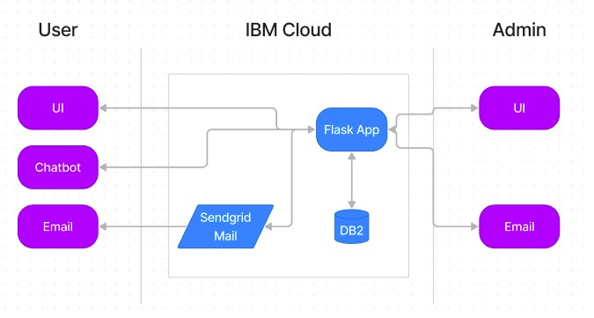

|  |  |  |  |
| --- | --- | --- | --- |
| **S.No** | **Characteristics** | **Description** | **Technology** |
| 1. | Open-Source Frameworks | Used Web technologies | HTML , CSS , JS , Python , Flask |
| 2. | Security Implementations | User verification through Email Service | Sendgrid |
| 3. | Scalable Architecture | Run the app in Local and Cloud System | Docker and Kubernetes |
| 4. | Availability | Justify the availability of application (e.g. use of load balancers, distributed servers etc.) | Docker , IBM Cloud |
| 5. | Performance | Design consideration for the performance of the application (number of requests per sec, use of Cache, use of CDN’s) etc. | IBM Cloud , Kubernetes Cluster , Container Registry |

**Table-1 : Components & Technologies:**

|  |  |  |  |
| --- | --- | --- | --- |
| **S.No** | **Component** | **Description** | **Technology** |
| 1. | User Interface | user interaction with application e.g. Web UI & Chatbot | HTML, CSS,Bootstrap JavaScript |
| 2. | Application Logic | Logic for a process in the application | Python - Flask |
| 3. | Email Service | For verify user and mail ads | SendGrid |
| 4. | Chatbot | Get details from user and store | IBM Watson Assistant |
| 5. | Cloud Database | Database Service on Cloud | IBM DB2 |
| 6. | Infrastructure (Server / Cloud) | Application Deployment on Cloud System | Docker, Cloud Foundry, Kubernetes, etc. |

**Table-2: Application Characteristics:**